**JAYA SAKTHI ENGINEERING COLLEGE**

**NM-DIGITAL MARKETING**

**Team ID : NM2023TMID05674**

**How to create a Brand Name ,brand**

**email, Brand logo in CANVA app..**

**Submission by,**

**Pradeep V G (Team leader)**

**Purusothaman V**

**Dhanush S**

**Rubesh M**

**Balaji H**

**Brand Name : RESPO LIFE CARE**

**BRAND E-mail :**

[**respolifecare@gmail.com**](mailto:respolifecare@gmail.com)

**Steps for email creation :**









**BRAND LOGO :**



**Steps to create brand logo :**

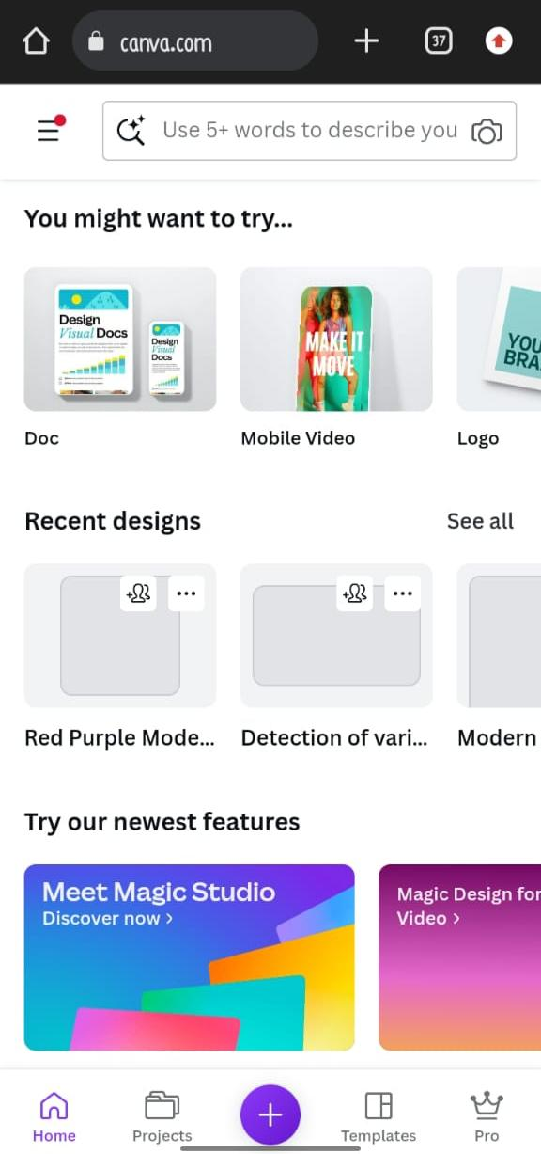

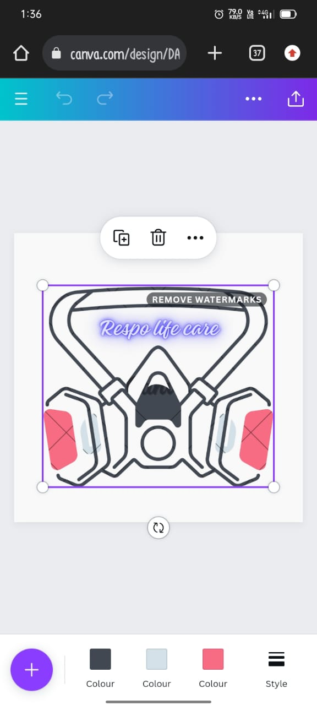

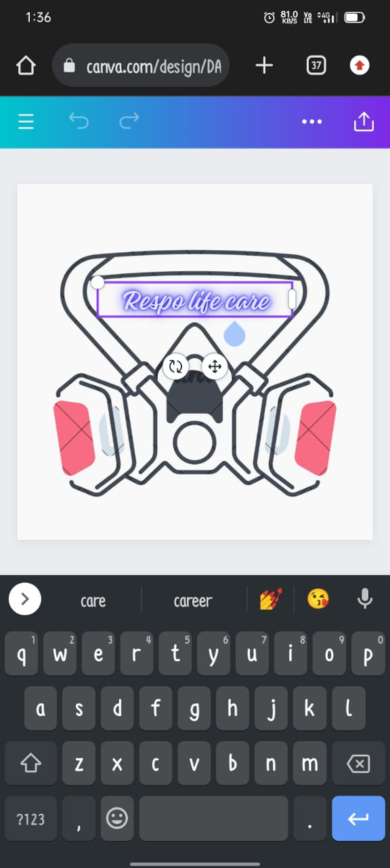

**Brand description :**

**Respo Life Care: Pioneering the Future of Respiratory Equipment**

**Introduction**

**In the dynamic landscape of healthcare, the respiratory equipment industry plays a pivotal role in enhancing the quality of life for millions worldwide. Among the industry’s leading torchbearers stands Respo Life Care, a visionary company dedicated to revolutionizing respiratory care. With a rich legacy of innovation and a commitment to excellence, Respo Life Care has become synonymous with cutting-edge technology and compassionate service.**

**Founding Vision**

**In the medical community, recognized the pressing need for advanced respiratory equipment that could cater to a diverse range of patients, from premature infants to elderly individuals battling chronic obstructive pulmonary disease (COPD).**

**Innovative Product Portfolio**

**Respo Life Care’s product portfolio is a testament to its unwavering commitment to innovation and patient-centric design. The company’s cornerstone products include state-of-the-art ventilators, nebulizers, oxygen concentrators, and CPAP (Continuous Positive Airway Pressure) machines. Each product undergoes rigorous research, development, and testing phases to ensure optimum efficacy, user-friendliness, and compliance with the highest industry standards.**

**The Ventilator Revolution**

**At the heart of Respo Life Care’s offerings lies its groundbreaking line of ventilators. These life-saving devices have been engineered with precision and empathy, striking an essential balance between advanced technology and intuitive usability. The company’s flagship model, the RespiroPro 5000, has garnered international acclaim for its ability to provide precise and personalized ventilation support to patients with diverse respiratory needs.**

**Global Reach and Impact**

**Respo Life Care’s influence extends far beyond its headquarters. With a network of distribution partners spanning over 50 countries, the company’s products touch the lives of millions worldwide. Whether in bustling urban hospitals, remote rural clinics, or even disaster relief efforts, Respo Life Care’s equipment stands as a beacon of hope and support for patients and healthcare providers alike.**

**Embracing Sustainability**

**Respo Life Care recognizes the crucial role it plays in safeguarding the environment. The company has implemented a robust sustainability program that includes responsible sourcing, energy-efficient manufacturing, and recycling initiatives. By adhering to strict eco-friendly practices, Respo Life Care not only minimizes its ecological footprint but also sets a commendable standard for the broader healthcare industry.**

**Customer-Centric Approach**

**What sets Respo Life Care apart is its unwavering focus on the end-users of its products. The company maintains an open channel of communication with healthcare professionals, gathering invaluable feedback to drive continuous improvement. Additionally, Respo Life Care offers comprehensive training and education programs to ensure that both clinicians and patients can maximize the benefits of its equipment.**

**Research and Development Excellence**

**Respo Life Care’s cutting-edge solutions are the result of a robust research and development ecosystem. The company collaborates with leading medical institutions, research centers, and technology experts to push the boundaries of what is possible in respiratory care. This commitment to innovation is evident in the numerous patents and accolades earned by Respo Life Care over the years.**

**Conclusion**

**Respo Life Care stands as a beacon of hope and innovation in the respiratory equipment industry. Guided by a founding vision of compassion and excellence, the company has set new standards in patient care and technological advancement. With a global footprint, a commitment to sustainability, and a relentless pursuit of excellence, Respo Life Care is poised to continue**